# Objective

To use radians and the unit circle to write an overloaded **polygon()** method and use these method(s) to draw a geometric shape.

## Topics: method calling, coordinate system, radians, unit circle, method overloading

# Instructions

Overload the **polygon()** method created in class so that you can alter other facts about a **polygon()**. Other facts to change include the fill color, how the lines are connected ( **strokeCap()** and **strokeJoin()**), how thick the outside edge will be (**strokeWeight()**), and an initial rotation. Use multiple calls (at least 8) to draw a design in your sketch. Notice in the examples that the method calls can take place on different coordinates on the screen.

# Examples

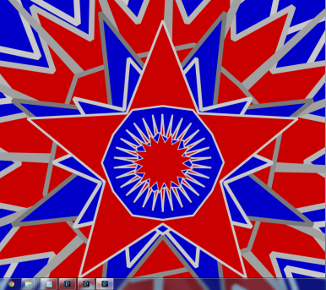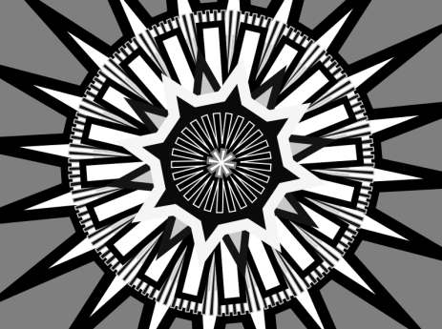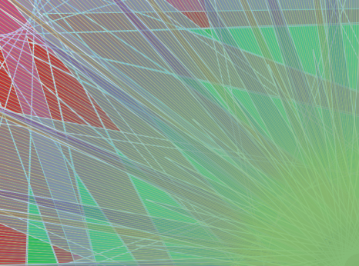

# Hints none

# Challenge

The middle sketch is created using a method called **sprocket()**. To generate a **sprocket()**, your for loop must generate *three* points per iteration instead of *two*. This means you will have to recalculate the amount of space (in radians) between the points in order to get an even sprocket. This is a hard challenge, drawing a picture can help.